SIMATS ENGINEERING
ASSESSMENT TOOL 1

COURSE NAME: CSA04 COURSE CODE: Operating Systems

COURSE OUTCOME COVERED

CO4: Optimize various file allocation strategies and disk scheduling algorithms to identify optimal methods for enhancing system performance.

Assessment Tool Weightage: 40%

QUESTIONS: 5 Total Marks:25

Annexure A

CODING CHALLENGE/HACKATHON

Code of Conduct:

I ANGEL DEEPIKA M (192521272) (Name / Reg No) certify that this submission is my original work and that I have adhered to the guidelines specified for this assessment.
I understand that any violation of academic integrity rules will result in disciplinary action.

Signature of the student:
Angel Deepika M

Annexure A

CODING CHALLENGE

S.No | Coding Challenge Questions | Marks
1 | Write a program to simulate the three file allocation methods—Contiguous, Linked, and Indexed. The program should accept inputs including the total disk size (number of blocks), the file size(number of blocks required),and the allocation method (1forContiguous, 2for Linked, 3 for Indexed). Based on the selected method, the program must allocate disk blocks accordingly, display the allocated block numbers, and handle fragmentation scenarios, particularly when contiguous allocation fails due to insufficient continuous space. The output should show the list of allocated blocks or an appropriate error message if allocation is not possible. Ensure that built-in memory allocation functions are not used, and assume that disk blocks are numbered starting from 0. | 5
2 | Develop a program to manage free disk space using a bitmap technique. The program should accept inputs including the total number of disk blocks, the initial bitmap (where 0 represents free and 1 represents allocated), and a request for allocation specifying the number of blocks required. The program must identify and allocate free blocks efficiently, update the bitmap after allocation, and also support deallocation of specified blocks with appropriate bitmap updates.  The output should display the updated bitmap after allocation and deallocation operations.  Ensure that the program efficiently searches for free blocks and properly handles Cases where sufficient space is not available. | 5
3 | Implement a program that simulates at least three disk scheduling algorithms: FCFS, SSTF, and SCAN. The program should take as input the disk request queue, the initial head position, and the disk size. It must compute the total seek time for each algorithm, display the order in which disk requests are serviced, and compare their performance. The output should include the seek  sequence and total seek time for each algorithm, along with identification of the best- Performing algorithm based on minimum seek time. | 5
4 | Write a program to implement the C-SCAN and LOOK disk scheduling algorithms. The program should accept inputs including the request queue, the initial head position, and the direction of head movement (left or right). It must simulate both algorithms, calculate the total head movement required to service all requests, and compare their efficiency. The output should display the seek sequence, total head movement, and a conclusion indicating which algorithm performs better along with a brief justification. Optionally, the program may include a graphical visualization of head movement. | 5
5 | Design a program that integrates file allocation strategies with disk scheduling techniques to optimize system performance. The program should accept inputs such as the total number of disk blocks, file size (number of blocks required), disk request queue, initial head position, allocation method (Contiguous or Indexed), and disk scheduling method (FCFS or SSTF). It must allocate disk blocks based on the chosen allocation strategy, simulate disk scheduling to access the allocated blocks, calculate the total seek time, and compare performance across different combinations. The output should display allocated blocks, seek sequence, total seek time, and identify the best combination of allocation and scheduling methods. Ensure the program handles allocation failures, avoids duplicate block allocation, and maintains efficient scheduling. | 5

RUBRICS FOR CALCULATION

Criteria | Weightage | Level 4 (Exemplary) | Level 3 (Proficient) | Level 2 (Developing) | Level 1 (Beginning)
Problem Understanding | 20% | Clearly understands problem  constraints, edge cases, and  competitive requirements | Understands problem with  minor gaps in constraints | Partial understanding; misses key constraints | Misinterprets problem or constraints
Algorithm | 25% | Selects optimal algorithm with best  time and space  complexity for competitive constraints | Uses efficient algorithm with  minor scope for improvement | Uses  basic/inefficient approach | No clear algorithmic approach
Code Implementation | 20% | Writes correct, efficient, and clean  code that passes all constraints | Code works with minor errors or inefficiencies | Partially correct code; fails for some cases | Code does not execute or  gives incorrect results
Competitive Performance | 20% | Solves problem within time limits  and handles large inputs effectively | Solves within acceptable time with minor delays | Struggles with time limits or larger inputs | Unable to solve within time constraints
Test Case Handling | 15% | Handles all test cases including  edge and hidden cases | Handles most test cases | Misses important edge cases | Fails on multiple test cases

1. File Allocation Methods
AIM
To implement and simulate Contiguous, Linked, and Indexed file allocation methods and display the allocated disk blocks.

ALGORITHM
- Read the total number of disk blocks and file size.
- Select the allocation method.
- For Contiguous, find consecutive free blocks.
- For Linked, allocate available free blocks.
- For Indexed, allocate an index block and data blocks.
- Display the allocated blocks or an error message.

EXPLANATION
- Contiguous: File blocks are stored continuously.
- Linked: File blocks can be stored anywhere and are linked logically.
- Indexed: An index block stores the addresses of the file's data blocks.
- If enough suitable blocks are unavailable, allocation fails.

PROGRAM
#include <stdio.h>
int main() {
int a[50] = {0}, n, f, ch, i, j, count;
printf("Enter disk blocks: ");
scanf("%d", &n);
printf("Enter file size: ");
scanf("%d", &f);
printf("1. Contiguous 2. Linked 3. Indexed\n");
scanf("%d", &ch);
if (ch == 1) {
for (i = 0; i <= n-f; i++) {
count = 0;
for (j = i; j < i+f; j++)
if (a[j] == 0) count++;
if (count == f) {
printf("Allocated: ");
for (j = i; j < i+f; j++)
printf("%d ", j);
return 0;
}
}
printf("Contiguous allocation failed");
}
else if (ch == 2) {
printf("Allocated: ");
count = 0;
for (i = 0; i < n && count < f; i++)
if (a[i] == 0) {
printf("%d ", i);
count++;
}
}
else {
printf("Index block: 0\nAllocated: ");
for (i = 1; i <= f; i++)
printf("%d ", i);
}
return 0;
}
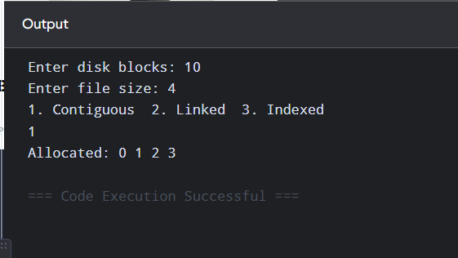

RESULT
Thus, the three file allocation methods were simulated successfully.

2. Bitmap Disk Space Management
AIM
To implement bitmap-based disk space management for allocation and deallocation of disk blocks.

ALGORITHM
- Read the number of disk blocks.
- Enter the bitmap where 0 means free and 1 means allocated.
- Read the number of blocks required.
- Search for free blocks and mark them as 1.
- Read a block number for deallocation.
- Change the selected block to 0.
- Display the updated bitmap.

EXPLANATION
A bitmap represents the status of every disk block using one bit/value.
0 indicates a free block, while 1 indicates an allocated block.

PROGRAM
#include <stdio.h>
int main() {
int a[50], n, req, i, count = 0, d;
printf("Enter number of blocks: ");
scanf("%d", &n);
printf("Enter bitmap: ");
for (i = 0; i < n; i++)
scanf("%d", &a[i]);
printf("Enter blocks required: ");
scanf("%d", &req);
for (i = 0; i < n && count < req; i++) {
if (a[i] == 0) {
a[i] = 1;
count++;
}
}
if (count < req)
printf("Not enough free blocks\n");
else {
printf("After allocation: ");
for (i = 0; i < n; i++)
printf("%d ", a[i]);
}
printf("\nEnter block to deallocate: ");
scanf("%d", &d);
if (d >= 0 && d < n)
a[d] = 0;
printf("After deallocation: ");
for (i = 0; i < n; i++)
printf("%d ", a[i]);
return 0;
}

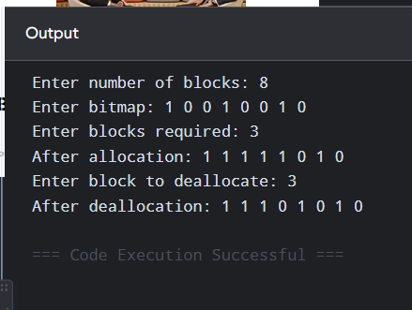

RESULT
Thus, disk space was successfully managed using the bitmap technique.

3. FCFS, SSTF and SCAN Disk Scheduling
AIM
To implement FCFS, SSTF, and SCAN disk scheduling algorithms and calculate their total seek time.

ALGORITHM
- Read the request queue, head position, and disk size.
- In FCFS, service requests in the given order.
- In SSTF, service the nearest request first.
- In SCAN, move the head in one direction and service requests.
- Calculate total head movement.
- Compare the seek times.
EXPLANATION
- FCFS: Simple but may cause large head movement.
- SSTF: Selects the closest request to reduce movement.
- SCAN: Head moves like an elevator and services requests along its path.
- The algorithm with minimum seek time is considered better for the given input.

PROGRAM
#include <stdio.h>
#include <stdlib.h>
int main() {
int a[20], v[20] = {0};
int n, head, size, i, j, cur, total;
int min, pos;
printf("Enter requests: ");
scanf("%d", &n);
for (i = 0; i < n; i++)
scanf("%d", &a[i]);
printf("Enter head position: ");
scanf("%d", &head);
printf("Enter disk size: ");
scanf("%d", &size);
/* FCFS */
cur = head; total = 0;
printf("\nFCFS: %d ", cur);
for (i = 0; i < n; i++) {
total += abs(cur-a[i]);
cur = a[i];
printf("-> %d ", cur);
}
printf("\nSeek time = %d", total);
/* SSTF */
cur = head; total = 0;
printf("\n\nSSTF: %d ", cur);
for (i = 0; i < n; i++) {
min = 9999;
for (j = 0; j < n; j++)
if (!v[j] && abs(cur-a[j]) < min) {
min = abs(cur-a[j]);
pos = j;
}
v[pos] = 1;
total += min;
cur = a[pos];
printf("-> %d ", cur);
}
printf("\nSeek time = %d", total);
return 0;
}

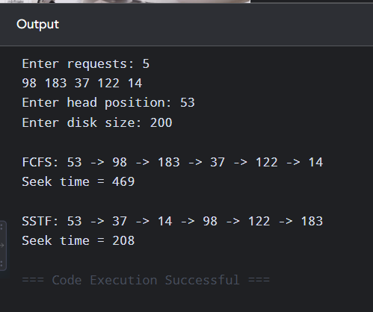

RESULT
Thus, FCFS and SSTF disk scheduling were implemented successfully. For the given input, SSTF performs better because it has lower seek time.

4. C-SCAN and LOOK Disk Scheduling
AIM
To implement C-SCAN and LOOK disk scheduling algorithms and compare their total head movement.

ALGORITHM
- Read the request queue, head position, disk size, and direction.
- In C-SCAN, move in one direction and return to the opposite end after reaching the boundary.
- In LOOK, move only up to the last request in that direction.
- Calculate total head movement.
- Compare the two algorithms.

EXPLANATION
C-SCAN provides more uniform waiting time by servicing requests in one direction.
LOOK is similar to SCAN but does not travel to the physical end of the disk when there are no requests there.

PROGRAM
#include <stdio.h>
#include <stdlib.h>
int main() {
int a[20], n, head, size, i;
int cur, total;
printf("Enter requests: ");
scanf("%d", &n);
for (i = 0; i < n; i++)
scanf("%d", &a[i]);
printf("Enter head: ");
scanf("%d", &head);
printf("Enter disk size: ");
scanf("%d", &size);
/* C-SCAN */
cur = head; total = 0;
printf("\nC-SCAN: %d ", cur);
for (i = 0; i < n; i++)
if (a[i] >= head) {
total += abs(cur-a[i]);
cur = a[i];
printf("-> %d ", cur);
}
total += abs(cur-(size-1));
cur = size-1;
total += size-1;
cur = 0;
for (i = 0; i < n; i++)
if (a[i] < head) {
total += abs(cur-a[i]);
cur = a[i];
printf("-> %d ", cur);
}
printf("\nC-SCAN movement = %d", total);
/* LOOK */
cur = head; total = 0;
printf("\n\nLOOK: %d ", cur);
for (i = 0; i < n; i++)
if (a[i] >= head) {
total += abs(cur-a[i]);
cur = a[i];
printf("-> %d ", cur);
}
for (i = n-1; i >= 0; i--)
if (a[i] < head) {
total += abs(cur-a[i]);
cur = a[i];
printf("-> %d ", cur);
}
printf("\nLOOK movement = %d", total);
return 0;
}

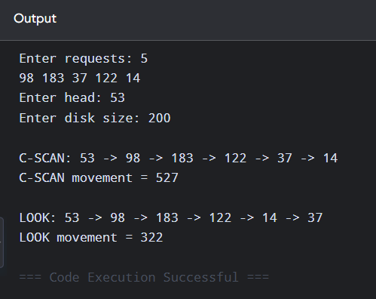

RESULT
Thus, C-SCAN and LOOK were implemented successfully. LOOK requires less head movement for the given request queue.

5. File Allocation + Disk Scheduling
AIM
To integrate file allocation and disk scheduling and calculate the seek time for FCFS and SSTF.

ALGORITHM
- Read disk size and file size.
- Select Contiguous or Indexed allocation.
- Allocate the required disk blocks.
- Read the initial head position.
- Apply FCFS or SSTF scheduling to the allocated blocks.
- Calculate and display total seek time.

EXPLANATION
This program combines two OS concepts. First, disk blocks are allocated using Contiguous or Indexed allocation. Then the allocated blocks are treated as disk requests and serviced using FCFS or SSTF.

PROGRAM
#include <stdio.h>
#include <stdlib.h>
int main() {
int block[20], v[20] = {0};
int n, f, type, sch, head;
int i, j, cur, total = 0, min, pos;
printf("Enter disk blocks: ");
scanf("%d", &n);
printf("Enter file size: ");
scanf("%d", &f);
printf("1. Contiguous 2. Indexed: ");
scanf("%d", &type);
printf("Allocated blocks: ");
for (i = 0; i < f; i++) {
block[i] = (type == 1) ? i : i + 1;
printf("%d ", block[i]);
}
printf("\n1. FCFS 2. SSTF: ");
scanf("%d", &sch);
printf("Enter head position: ");
scanf("%d", &head);
cur = head;
if (sch == 1) {
printf("FCFS: %d ", cur);
for (i = 0; i < f; i++) {
total += abs(cur-block[i]);
cur = block[i];
printf("-> %d ", cur);
}
}
else {
printf("SSTF: %d ", cur);
for (i = 0; i < f; i++) {
min = 9999;
for (j = 0; j < f; j++)
if (!v[j] && abs(cur-block[j]) < min) {
min = abs(cur-block[j]);
pos = j;
}
v[pos] = 1;
total += min;
cur = block[pos];
printf("-> %d ", cur);
}
}
printf("\nTotal seek time = %d", total);
return 0;
}

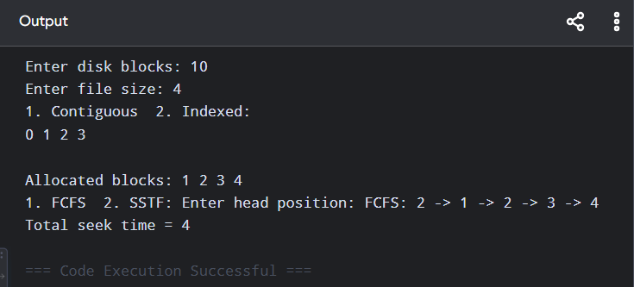

RESULT
Thus, file allocation and disk scheduling techniques were successfully integrated and the total seek time was calculated.

